Super Resolution (https://arxiv.org/pdf/1609.05158.pdf)

Super resolution is the process of upscaling and or improving the details within an image. Often a low resolution image is taken as an input and the same image is upscaled to a higher resolution, which is the output. The details in the high resolution output are filled in where the details are essentially unknown.

The global SR problem assumes LR data tobe a low-pass filtered (blurred), downsampled and noisyversion of HR data. It is a highly ill-posed problem, dueto the loss of high-frequency information that occurs dur-ing the non-invertible low-pass filtering and subsamplingoperations.

A key assumption that underliesmany SR techniques is that much of the high-frequency datais redundant and thus can be accurately reconstructed fromlow frequency components.

single image super-resolution (SISR) techniques seek to learnimplicit redundancythat ispresent in natural data to recover missing HR informationfrom a single LR instance. This usually arises in the form oflocal spatial correlations for images and additional temporalcorrelations in videos.

Objective: To increase the resolution from LR to HR only at the very end of the network and super-resolve HR data from LR feature maps. This eliminates the need to perform most of the SR operation in the far larger HR resolution.

Fractionally-strided covolution or transposed convolution
A transposed convolution is somewhat similar to deconvolution because it produces the same spatial resolution a hypothetical deconvolutional layer would. However, the actual mathematical operation that’s being performed on the values is different. A transposed convolutional layer carries out a regular convolution but reverts its spatial transformation.
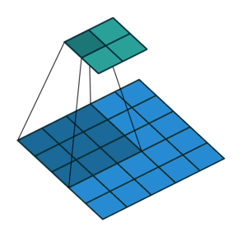
2D convolution with no padding, stride of 2 and kernel of 3
An image of 5x5 is fed into a convolutional layer. The stride is set to 2, the padding is deactivated and the kernel is 3x3. This results in a 2x2 image.
If we wanted to reverse this process, we’d need the inverse mathematical operation so that 9 values are generated from each pixel we input. Afterward, we traverse the output image with a stride of 2. This would be a deconvolution.

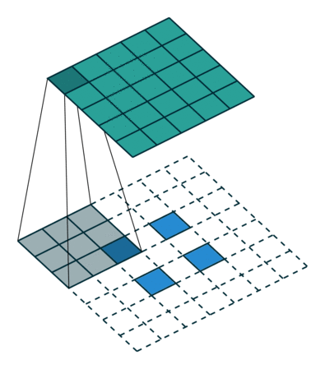
Transposed 2D convolution with no padding, stride of 1 and kernel of 3
A transposed convolution does not do that. The only thing in common is it guarantees that the output will be a 5x5 image as well, while still performing a normal convolution operation. To achieve this, we need to perform some fancy padding on the input.
This step will not reverse the process from above. At least not concerning the numeric values.
It merely reconstructs the spatial resolution from before and performs a convolution. This may not be the mathematical inverse, but for Encoder-Decoder architectures, it’s still very helpful. This way we can combine the upscaling of an image with a convolution, instead of doing two separate processes.

As we saw above, to perform fractionally-strided convolution we need to perform some kind of padding/shuffling on the input pixels. This is the main concept behind implemennting the super resolution.
In the paper discussed, as the input will be shuffled, different elements of the kernel will get activated for the convolution operation (transposed convolution). The weights that fall between the pixels are simply not activated and need not be calculated for convolution.
~Note: nn.PixelShuffle(upscale_factor) have the same affect of shufling the pixel and the applying convolution as discussed above
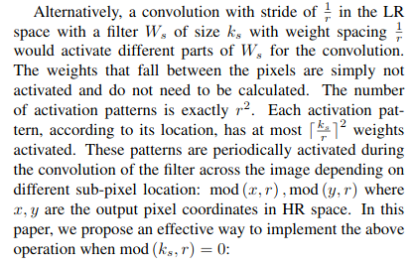

PyTorch’s nn.PixelShuffle(upscale_factor) rearranges the elements (input) in a tensor of shape (batch_size, C*upscale_factor, H, W) to a tensor of shape (batch_size, C, H*upscale_factor, W*upscale_factor) . This produces a high resolution output image.

The error function used in this task is the Mean Squared Error (MSE). PSNR is used as a performance metric to evaluate the models.

PSNR = 10*log10(1/MSE)

Note:
1. The training and validation set images are rezized for the purpose of training and validation. The input image are of size 84 (approximately) and the ouput images are of size 255 (approximately). However, during testing the images need not be resized and the output will have the super resolution effect.

2. The model is actually upscaling the images. During training/validation, comparing the original images (of size ~224) with the output of our model (images of size ~ 255) does not make sense. (We can compare the resized images with the model output).

Resources
1. https://beerensahu.wordpress.com/2018/04/10/pytorch-a-fractionally-strided-convolution-or-a-deconvolution/
2. https://towardsdatascience.com/types-of-convolutions-in-deep-learning-717013397f4d
3. https://medium.com/@fanzongshaoxing/accelerate-pytorch-model-with-tensorrt-via-onnx-d5b5164b369
4. https://en.wikipedia.org/wiki/Semi-orthogonal_matrix

